NAME: _____________ | Statistics and Probability
8-3 Confidence Intervals d2 | DATE: Tuesday, January 12, 2016

Intervals: Problems where we conduct a sample and want to predict population proportion.
Where:
- p is the proportion in your survey who said one result
- n is the sample size. This is the size of your sample.
- Z is below
  - 90% confident = 1.64
  - 95% confident = 1.96
  - 99% confident = 2.57

Practice problems:

As part of a quality improvement program, your mail-order company is studying the process of filling customer orders. According to company standards, an order is shipped on time if it is sent within 3 working days of the time it is received. You select a simple random sample (SRS) of 100 of the 5000 orders received in the past month for an audit. The audit reveals that 86 of these orders were shipped on time. Find a 95% confidence interval for the true proportion of the month’s orders that were shipped on time. | The Gallup Poll asked a sample of 1785 adults, “Did you, yourself, happen to attend church of synagogue in the last 7 days.” Of the respondents, 750 said “Yes.” Suppose (it is not, in fact, true) that Gallup’s sample was random. Give a 99% confidence interval for the proportion of all U.S. adults who attended church or synagogue during the week preceding the poll.
An appliance manufacturer stockpiles washers and dryers in a large warehouse for shipment to retail stores. Sometimes, handling them the appliances get damaged. Even though the damage may be minor, the company must sell those machines at drastically reduced prices. One day an inspector randomly checks 60 washers and finds that 5 of them have scratches or dents. Compute a 95% confidence interval for the proportion of appliances from this manufacturer that  get damaged during shipment. | ADVANCED:  It is believed that as many as 25% of adults over 50 never graduated from high school. We wish to see if this percentage is the same among the 25 to 30 age group. How many of this younger age group must we survey in order to estimate the proportion of non-grads to within 6% with 90% confidence?

Hypothesis Testing:
When you start with a claim and test your result and see how likely that result would be IF THE CLAIM WAS TRUE.

Example:
Burger King says 65% of people prefer their fries to McDonalds. You want to test this claim. You survey 120 people and find 65 people like Burger King Fries more (which is 54.2%). Do you have evidence (at 95% level) that Burger King is wrong in their figure.
Steps:
- Assume the claim is true. | - Lets go with Burger King’s figure 65% is true.
- Find mean and standard deviation.  Mean is claimed percentage  standard deviation is | 2. So if claim is true and we sampled 120 people, the mean percentage should be 65% and the  Standard deviation would be:
- Now put in calculator online  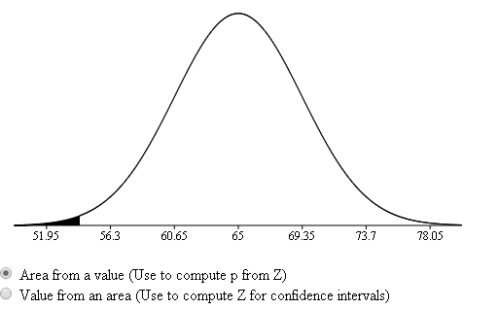 | 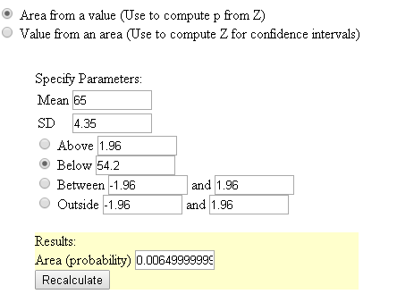
- Make conclusions  - if probability is really small (below .05 usually)– you have evidence original claim is false  - else you have no evidence claim is false (doesn’t mean claim is true) | 4. If Burger Kings claim is true, there is only a .65% chance we would have gotten so few people choosing Burger King fries. We have evidence that the original percent 65% is not true.

Practice Hypothesis Testing
You are told that the percent of students at Deering who are on honor role is 44%. For a final project, Hua conducts a survey of 120 students and found that only 30% are on honor role. If the true stat is 44%, what is the chance that you would have gotten an answer 30% or farther off just by chance?  Does Hua have reason (at 95% confidence [which is .05 signicance level]) to doubt Deering’s admin’s statement? | Donald Trump says he is getting 45% of voters in Maine. The Press Herald thinks it is much less. They conduct a survey of 358 people around the state and find that 122 people said they support him. What is the chance if Donald Trump’s figure is right, that the Press Herald would have gotten a figure as low as that or lower just by chance?  Does the Press Herald have reason (at .05 significance level) to doubt his statement?
Lets year Anthony made only 42% of his free throw shots. He practiced like crazy over the off season. This year, he has made 21 out of 38 free throws. What is the chance that Anthony would have shot this way, if he really is a 42% free throw shooter?  Do we have evidence (at .05 significance level) that he is a better shooter this year? | Eleven percent of the products produced by an industrial process over the past several months fail to conform to the specfications. The company modifies the process in an attempt to reduce the rate of nonconformities. In a trial run, the modified process produces 16 nonconforming items out of a total of 300 produced. Do these results demonstrate that the modification is effective? (at .01 significance level)

